

Volunteers’ Management System
User Manual for Managers

By:
Apollo Group

Table of Contents
Content Page #

Table of Contents 3
1 Introduction 3
2 About VMS Portal 4
3 How to 5
3.1 How to register and login 5
3.2 How to ceate and edit crisis 6
3.3 How to create and edit incident 7
3.4 How to create and edit requests to volunteers 8
3.5 How to search and send alert to volunteers 8
4 Troubleshooting 9
5 Installation guidelines 10
6 Glossary 11
7 Revision histroy 12

Introduction

This document will help VMS Managers to know about different functionalities of the system. So they can perform their operations in a more effective and better way.

As a manager, you may also refer this manual for later use. It explains what procedures you may follow to perform each task.

It’s structured in a way, so you find it easy to start operating it. It first explains you how to define a crisis location and then how to operate incidents within that. Later it explains other options in VMS.

You may also take required help from Glossary.

About VMS

VMS (Volunteers’ Management System) is solution developed for help organizations (for e.g. Red Cross) to utilize citizens as volunteers, during crisis time.

VMS can be viewed as 2 separate parts, one is VMS Mobile/Client Application and the other is VMS Portal Application. Using VMS Portal, help organizations can communicate with the volunteers, by asking them for resources (e.g. car, medicine, expertise). VMS Manager should have enough knowledge and expertise in managing crisis in real life. So with the help of VMS he/she can manage relief operations more effectively and in less time.

Manager can access VMS Portal application, on the web. Where he/she can define crisis in the system.

How To

How to register and login

Steps to register:
- In order to register, please select user type as ‘Manager’ in Manager registration page, then click ‘Register’ button
- You’ll see registration form, where you need to fill-in your profile detail
- There you’ll also be asked to enter your expertise area in incident type section. For example Fire rescue, bombing, etc.
- Click at Register button

Once registration form filled and submitted. Your profile will go for approval to Manager responsible for approval. After registration you’ll be guided to login page again, in order to login.
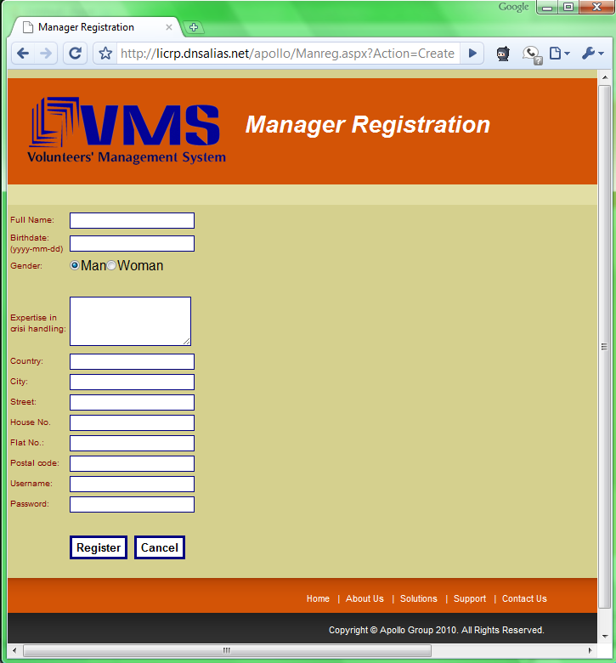
Figrure 3.1 (a)

Steps for login:
- To access the system, please enter username and password
- Then select ‘Manager’ as user type and click ‘Login’
- Then you’ll be guided to the main page in order perform operations required
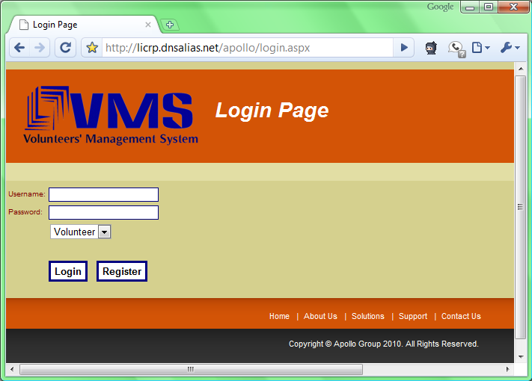
Figure 3.1 (b)

How to create

Steps to create:
- After login in the application, you’ll be guided to the main page
- Then you’ll see new Crisis Information Page containing the map.
- Enter a name for crisis in ‘crisis name’ field
- Define the area on the map by selecting the area and then clicking it
- Select type of the crisis from a list
- Enter details of crisis, in explanation field
- Then click on save button.
- Then you’ll be guided to the Management main page to perform rest of the operations.
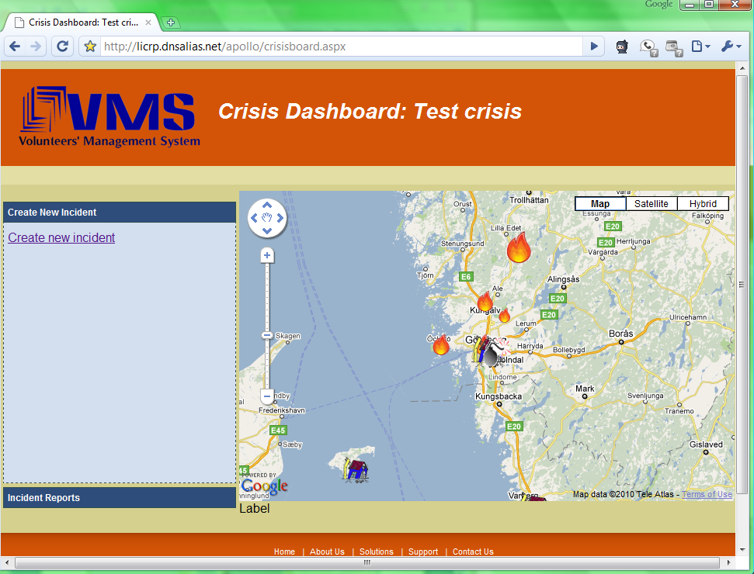
Figure 3.2

Steps to edit or close crisis:
- In order to edit, please select an active crisis and then click on ‘edit crisis’; or to close you only need to click ‘close’ button so this will close the crisis for you.
- If you clicked edit, system will guide you to the page, where you can edit information for the crisis. And then save when you click ‘Save’ button.

How to create incidents

Steps to create:
- To define incident in any active crisis in VMS, click ‘Create incident’ from main page
- It’ll show you the form, which incident related details required.
- You’ll be asked to select in the following sequence:
- Please select the incident area on the map. When you click any specific area, it’ll be saved in the form. You may use search facility on the bottom-left side of the map, to search area by name
- Then select Incident type, where you can define Fire, Bomb, Accident, or any other from options available. Then its severity.
- Then short description about this incident
- In Need List, you need to put needed items one-by-one.
- Enter short address, to assist volunteers to find accurate place
- Click ‘Save’ button, to add incident in the system.
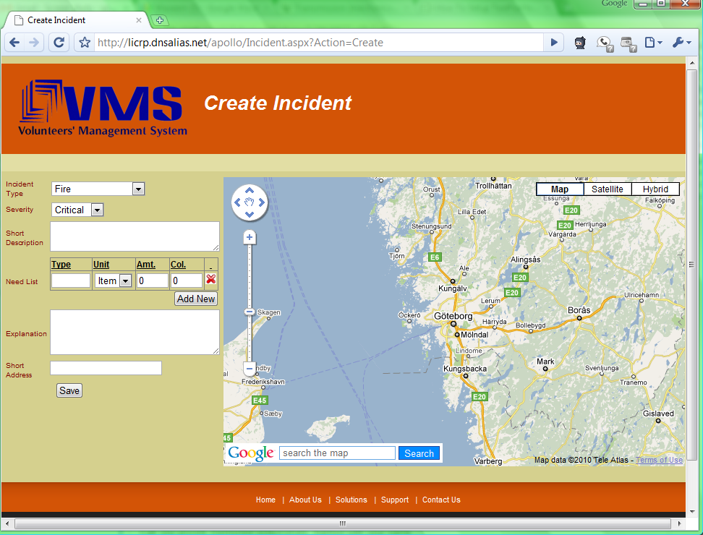
Figure 3.3

Steps to edit:
- In order to edit incident, you may select listed incidents from main page
- It’ll show you the form to edit the information
- Please make the required changes you want to do in incident
- And then press ‘Save’ button

Steps to close:
- To close incident, select incident from crisis main page
- Then click at ‘close incident’ option
- A confirmation-window will pop-up, please select ‘OK’. Then incident will be closed.

How to create and edit requests

Steps create:
- As manager you may find the Volunteers whom you want to send requests, by searching them
- Then select incident for requests, and then click ‘create request’
- It’ll open request form for you, where you can enter the message for Volunteers.
- Then select the needed item which you want to request in this message
- Click ‘Save’, then messages will be sent to the recipient volunteers

Steps edit:
- Manager may also make changes in the requests for particular incident, by selecting incident and clicking ‘edit request’
- It’ll open form, where message and needed items can be changed
- Click ‘Save’, then requests will be sent automatically to the volunteers.

How to search and send alert to volunteer

Steps to search:
- On crisis management main page, you need to select area where you want to search volunteer(s)
- Then in search box, write the search text, and click ‘Search’ button
- It’ll show you the list of volunteers.

Steps to send alert:
- Please select volunteers whom you want to send alert. And click ‘send alert’
- It’ll show you the form where you can enter message
- Then click ‘send button. It’ll be sent to the mobile application of Volunteer(s).

Troubleshooting
TBL

User Guidelines
TBL

Glossary

Manager: | Person who responsible for managing Volunteer management system, and is part of the help organization.
Volunteer: | The people who will use the VMS for helping other people on /before/after to the crisis, but not with the administrative responsibilities.
Crisis: | In VMS, manager defines crisis which is can have one or more incidents defined in it. (Refer: 'incident')
Incident: | Incident is any kind of unexpected and non-routine event that can cause trouble to the human beings normal day to day life.
Need List: | List of needed items, which are required in relief work for the incident
VMS: | Volunteer management system is also referred as VMS
Map: | In VMS, you can define location in the map area.
Mobile application: | This is an application which Volunteers use on their mobile phone. For all communication between help organization and volunteer, Volunteer uses this application
Web application: | Manager uses this web application, where all crisis related activities can be performed. And management of volunteers can be done.

5. Revision History

Name | Date | Description | Version
Waseem Soomro | 25 Apr 10 | Created a User-Manual with initial outline | 0.1
Waseem Soomro | 03 May 10 | Revised Introduction and How To sections | 0.2
Waseem Soomro | 04 May 10 | Revised Glossary, How To sections | 2.0
Gilana,  Mustafa, | 05 May 10 | Reviewed | 2.1
Waseem Soomro | 05 May 10 | Added About VMS part, added screenshots, and fixed defects | 2.1
Team | 05 May 10 | Shared to the peer group (Evolution) for review | 2.2
Waseem Soomro | 06 May 10 | Changes made after peer-review-comments | 3.0

